**SMART HOME**

A COURSE PROJECT REPORT

By

**Neha Bhardwaj[RA2111028010104]**

**Madunuri Harshini[RA2111028010112]**

Under the guidance of   
**Prabhakarn J.***In partial fulfilment for the Course*

of

18CSS202J - COMPUTER COMMUNICATIONS

in NWC



**FACULTY OF ENGINEERING AND TECHNOLOGY**

**SRM INSTITUTE OF SCIENCE AND TECHNOLOGY**

**Kattankulathur, Chenpalpattu District**

April 2023

**SRM INSTITUTE OF SCIENCE AND TECHNOLOGY**

**(Under Section 3 of UGC Act, 1956)**

**BONAFIDE CERTIFICATE**

Certified that this mini project report "**SMART HOME**" is the bonafide work of

**Neha Bhardwaj[RA2111028010104]**

**Madunuri Harshini[RA2111028010112]**

who carried out the project work under my supervision.

# SIGNATURE

Prabhakarn J.

# Assistant Professor

**NWC**

SRM Institute of Science and Technology

**Table Of Contents**

|  |  |  |
| --- | --- | --- |
| **S.No** | **TITLE** | **Page.No** |
| **1** | **ABSTRACT** | **3** |
| **2** | **OBJECTIVE** | **4** |
| **3** | **INTRODUCTION** | **5** |
| **4** | **MODULES** | **8** |
| **5** | **DEVICE CONFIGURATION** | **9** |
| **6** | **COMPONENTS** | **10** |
| **7** | **RESULT** | **11** |
| **8** | **REFERENCES** | **12** |

### **ACKNOWLEDGEMENT**

We express our humble gratitude to **Dr C. Muthamizhchelvan**, Vice-Chancellor, SRM Institute of Science and Technology, for the facilities extended for the mini project work and his continued support. We extend our sincere thanks to Dean-CET, SRM Institute of Science and Technology, **Dr T.V.Gopal**, for his valuable support.

We wish to thank **Dr Revathi Venkataraman**, Professor & Chairperson, School of Computing, SRM Institute of Science and Technology, for her support throughout the project work. We are incredibly grateful to our Head of the department**, Dr. Annapurani Panaiyappan.K** Professor, Department of Networking and Communications, SRM Institute of Science and Technology, for her suggestions and encouragement at all the stages of the project work.

Our inexpressible respect and thanks to our guide, **Dr. D. Saveetha,** Assistant professor, Department of Networking and Communications, SRM Institute of Science and Technology, for providing us with an opportunity to pursue my project under her mentorship. She provided us with the freedom and support to explore the research topics of our interest. Her passion for solving problems and making a difference in the world has always been inspiring.

We sincerely thank the Networking and Communications Department staff and students, SRM Institute of Science and Technology, for their help during our project. Finally, we would like to thank parents, family members, and friends for their unconditional love, constant support, and encouragement.

# ABSTRACT

### The technology has been growing from day to day in human life. The necessity for the development of technology is to lead human life comfortably. The basic need of human to lead his/her life comfortably is a home. A home with updated latest technology which means a smart home. This paper gives the basic idea use cisco packet tracer to implement smart home. One is needed to create a smart home when electronic devices are switched on and off. Smart home development is achieved by simulation via testing system, network setup and wireless home gateway computer network equipment required by a smart home network cisco packet tracer. The software chosen for the simulations is Cisco Packet Tracer, the tool's main strength is to offer a variety of network components that represent a real network, and then interconnect and configure devices to create a network and add all the smart devices, sensors and actuators

# OBJECTIVE

The main objectives of the smart home is to ease daily life by increasing user comfort. It does this by automating typical routines as well as giving homeowners the power to manage their home systems remotely. By automating many aspects of daily living through remote technology, a smart home provides the ability to control electronics and appliances from a smartphone, tablet or laptop. It adds an extra level of convenience and comfort while eliminating the burden of manually maintaining home systems.

A smart home with integrated e-health and assisted living technology can play a pivotal role in revolutionizing the healthcare system for the elderly, the disabled and those with functional limitations.

The big advantages of smart house

1. **Managing all your home gadgets from a single venue:** - The convenience factor here is enormous. Being able to keep all of the technology in your home connected through one interface is a massive step forward for technology and home management.
2. **Flexibility for modern appliances and computers**: - When it comes to accommodating modern gadgets and appliances and other technologies, smart home solutions seem to be wonderfully versatile. No matter how state-of-the-art your appliances seem today, as time goes by, newer, more amazing versions will be created.
3. **Maximizing comfort at home**: - Your home security can skyrocket when you integrate security and surveillance features into your smart home network. There are lots of possibilities here—only a few hundred of which are being discussed at present.
4. **External Home Feature Power**: - Do not underestimate the strength of being able to control the operations of your home from a distance. You will order your house to become cooler in just enough time on an unusually hot day before you get home from work.
5. **Increased quality of electricity**: - It’s important to make your room more energy efficient based on how you use your smart-home technology.
6. **Insights into Home Management**: - There's also plenty to be said for your desire to think about how your house works.

# INTRODUCTION

In today's technologically growing world technological development without becoming a requirement that is frequently used in today’s human life. Living home that includes smart objects with specific functions is called smart home. i.e aimed to improve safety, comfort and efficiency, which can be used to automate home activities without users using various sensors (Temperature, Humidity, Smoke, Wind, Sound) to monitor the home environment. And there are usually monitoring tools, and the devices that are controllable and automatic this can be accessed via an internet-connected computer or smart mobile device. Instead of providing security that is safe, smart home can provide different features to provide automatic security using various alarm systems, as LCD display and siren sound and by sending email to valid users if sensor detects security issues. Home automation states handling and monitoring home items using microcontroller or computer technology. Automation is common because it makes the process simple , productive and secure. All smart devices are registered at the home gateway in this paper and operated by a legitimate person. By including different sensors in home automation, Smart Home eliminates user engagement in tracking home settings and operating home appliances. This paper describes the implementation of smart home with the use of latest version of cisco packet tracer as this version includes different sensors, actuators and smart devices used for home automation. Chic lights, chic windows, chic fans, chic doors with different detectors and sensors are some of the devices .

# MODULES

1. The above figure indicates that the smart entity is connected via Ethernet cable and wireless media to the home gateway to manage the smart system locally and remotely

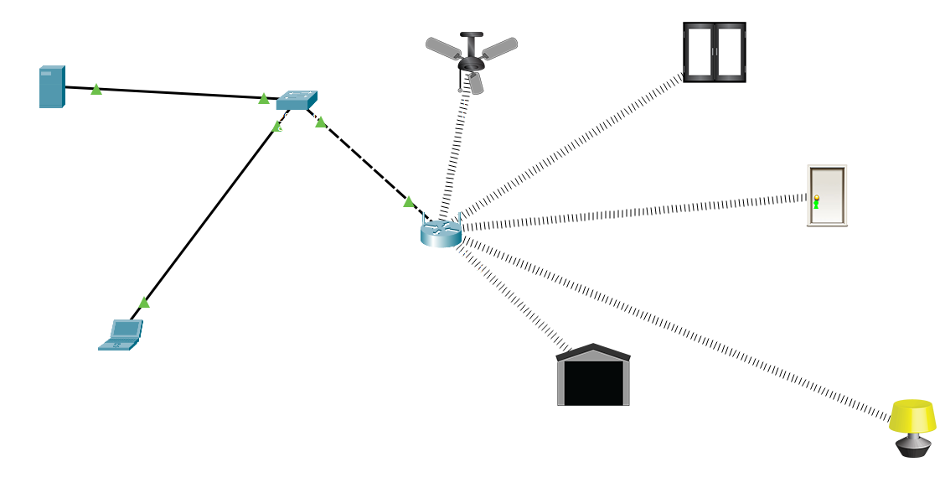

1. In addition to a wireless access point equipped with the "Home Gateway" SSID, the Home Gateway has 4 Ethernet ports (see Fig 2). WEP / WPAPSK / WPA2 can be configured on the home gateway for secure wireless connection.

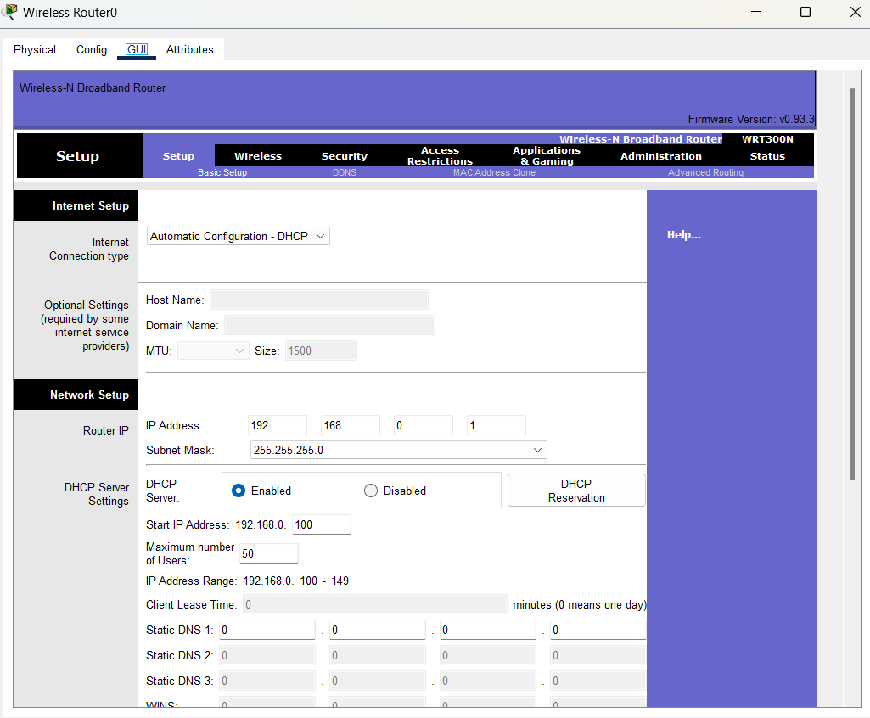

1. We used multiple sensors, smart devices to make them smarter to incorporate smart home using cisco packet tracer. The following figure represents the home architecture that uses wireless media to communicate with each other.



# DEVICE CONFIGURATION

## Server Configuration:

## Assigning IP Address for Server

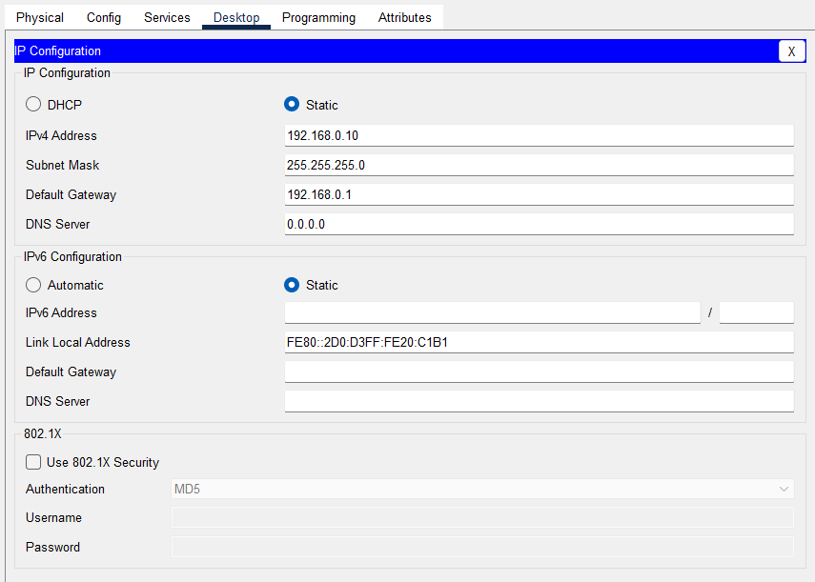

**Router Configuration:**

**Assigning IP Address for Router**

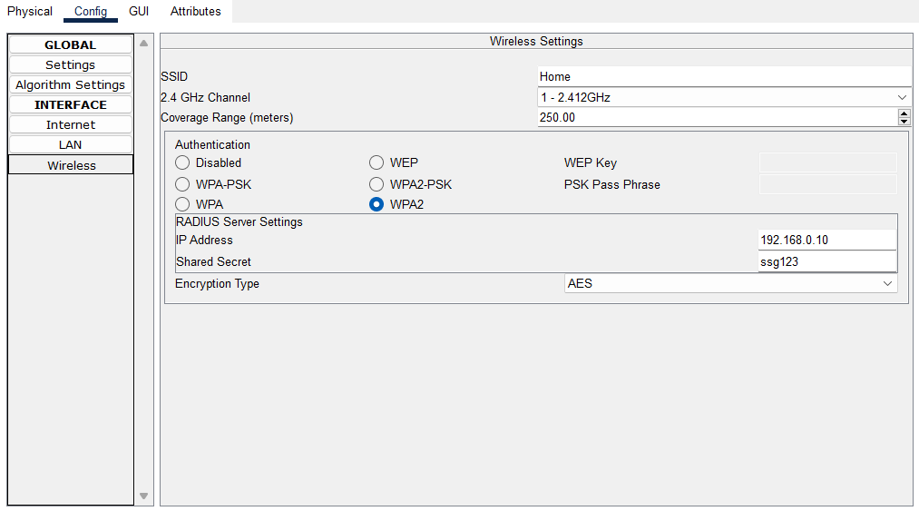

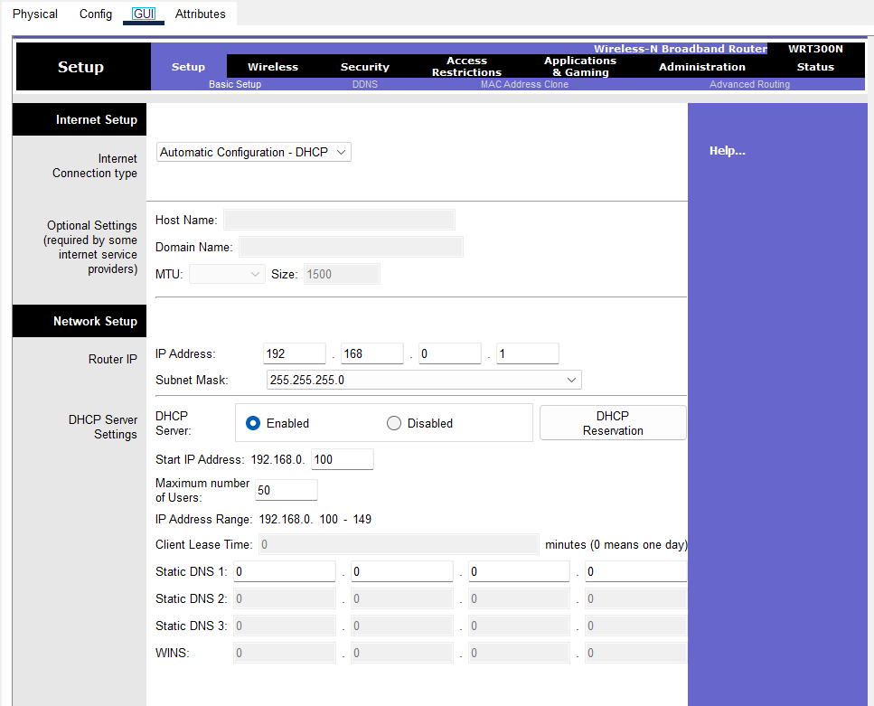

# COMPONENETS

### Smart door- our home getaway and have event-based features

### Light- provide light

### Fan- Centered on a certain state, used to ventilate the home air

### Garage Door- Garage gateway

### Laptop- Link to a home gateway for smart object control

### Server- Used to connect to the router's cellular device

### Home gateway- Used for smart object registration and smart object IP address transmission

### Cable - Use for connect home to the internet

# RESULT

The paper outlined the steps involved in structure network design and deployment for a small office home office need. It presented the steps (or phases) of a structured network design and demonstrated a practical implementation of the steps. The design was first simulated using Cisco Packet Tracer software.

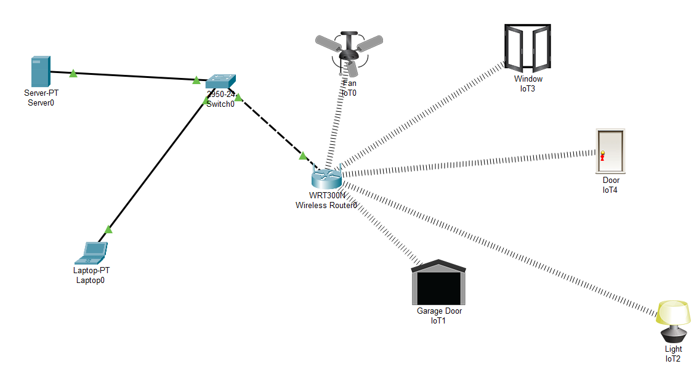

# REFERENCES

[1] **Priscilla Oppenheimer, (2010).** “Top-Down Network Design”, 3rd ed. Cisco Press, Indianapolis, USA [2]Meraki Inc. (2011). “Network Design Guide” online+ Available at <http://meraki.cisco.com/lib/pdf/> meraki_setup_network_design.pdf

1. **Cisco Packet Tracer Brochure**, <http://www.cisco.com/web/learning/neta> cad/downloads/pdf/ PacketTracer5_0_DS_0703.pdf
2. **Wikipedia**, <http://en.wikipedia.org/wiki/Bandwidth_(c>omputing)
3. **Wikipedia**, <http://en.wikipedia.org/wiki/WiFi_Protected_Access>

**THANK YOU**